Two Stage op-amp

Opamp

Waveform

Q1

V’’ Charge injection error at 5ns before and after clk1a turns off = 4.3mV

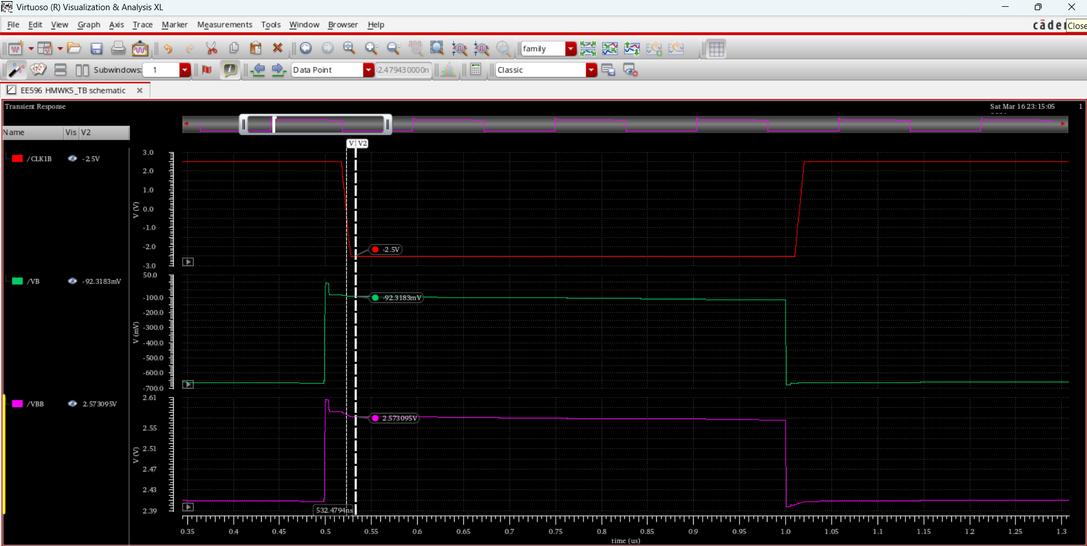

Q2. Time for V’ and V’’ to settle is 281.43ns

Q4 A)

CI error at +- 1.5v =0.28v

B) When W3 = 2u, CI = 0.33v

